MySQL Cambiar passowrd del usuario Root

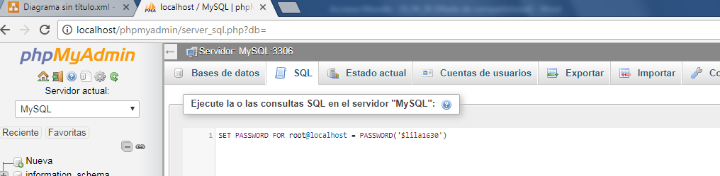

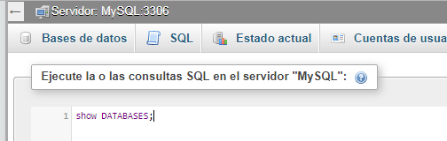

SQL:

Show DATABASES; - Muestra bases de datos en el sistema

CREATE DATABASE TEST0; - Crea base de datos

USE TEST0; - Usa la nueva base de datos creada

**Creamos los campos de la base de datos:**

CREATE TABLE TEST0 (

PersonID int,

LastName varchar(255),

FirstName varchar(255),

Address varchar(255),

City varchar(255)

);

**Insertar datos**

INSERT INTO test0 (`PersonID`,`FirstName`,`LastName`,`Address`,`City`)

VALUES (0,"Jose","Maria","rambla 1","vilanova i la geltru");

**Mostrar información de la tabla**

SELECT * FROM `persona` - Todos los campos

SELECT `LastName` FROM `persona` - Solo campo Last Name

SELECT `LastName`,`PersonID` FROM `persona` - Mostrar dos campos

SELECT * FROM `persona` WHERE `PersonID` >= 1 - Condicion sobre el Person ID

**Mezcla de tablas**

Asignamos alias al fichero coches = X coches AS x

Asignamos alias al fichero persona = Y persona AS y

SELECT y.PersonID, x.CocheID FROM coches AS x, persona AS y;

**Tiempo importacion de la base de datos**

A better solution here is to change the config that controls phpMyAdmin and not the php.ini file.

If you change the php.ini file you effect everything in PHP and should you write that infinite loop that we all do from time to time it will take longer to terminate your infinite loop than is sensible.

**Note:** If you are using the 64bit WAMPServer the base folder name will be wamp64 instead of wampso please amend the below folder names accordingly.

So change \wamp\alias\phpmyadmin.conf. By default it will look something like this although your version of phpMyAdmin will probably be different:

Alias /phpmyadmin "c:/wamp/apps/phpmyadmin4.1.14/"

<Directory "c:/wamp/apps/phpmyadmin4.1.14/">

Options Indexes FollowSymLinks MultiViews

AllowOverride all

<IfDefine APACHE24>

Require local

</IfDefine>

<IfDefine !APACHE24>

Order Deny,Allow

Deny from all

Allow from localhost ::1 127.0.0.1

</IfDefine>

php_admin_value upload_max_filesize 128M

php_admin_value post_max_size 128M

php_admin_value max_execution_time 360

php_admin_value max_input_time 360

</Directory>

To extend the maximum time limit for importing a database, change the php_admin_value max_execution_time parameter. You may also need to change the other parameters as larger databases tend to come in larger files and take longer to read as well. Example:

php_admin_value upload_max_filesize 1024M

php_admin_value post_max_size 1024M

php_admin_value max_execution_time 1800

php_admin_value max_input_time 1800

Don't forget to **restart Apache** after making changes to this file.

DATE_ADD(date, INTERVAL value unit)

DATE_ADD (campofecha, 1 year) o ` -2 year` o `3 months`